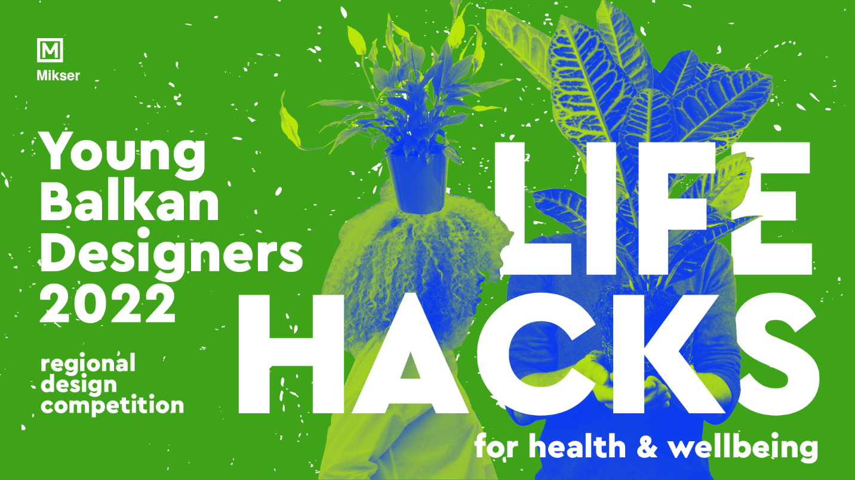
Press release / December 8, 2021
REGIONAL DESIGN COMPETITION
YOUNG BALKAN DESIGNERS 2022:
Life Hacks for Health and Wellbeing

Mikser Association proudly announces the new edition of its signature design competition Young Balkan Designers whose theme for 2022 - “Life Hacks for Health & Wellbeing” calls for design projects, objects, concepts, services, scenarios and inventions which create a “shortcut” between sustainable living and wellbeing, provoking conversation on alternative re-imagining healthier everyday worlds: at home, at school or work, in public, in our intimate and community spaces, urban and rural environments, in our physical and digital realms.
The competition is open from 8 December, 2021 till 20 January, 2022 to teams and individuals up to 35 years of age, from the following countries: Albania, Austria, Bosnia and Herzegovina, Bulgaria, Croatia, Greece, Hungary, Macedonia, Montenegro, Romania, Slovenia, Serbia and Turkey. Applicants may be individuals or groups of creators. Each applicant may submit more than one entry.

The competition challenges young designers to emerge positively from the pandemic and come up with unconventional, witty interventions and “fixes” which contribute to life-promoting environments and use nature-based solutions to address physical health, but also enhance the experiences of human-nature interactions, social connections, belonging and multitude of other positive emotions through engagement of all senses, addressing neglected needs, or introducing quite surprising and unexpected functionalities, etc.
We encourage young creators to surpass limitations and dependency on massive, industrial production and lead the way towards self-sustenance and easily personalized solutions, increase of inclusion and equality by creating a choice & flexibility for different needs and supporting members of families, teams, communities and social networks to develop and maintain healthy lifestyles and come together to help each other.
The proposed projects should not necessarily have the ambition to “leave a mark” but, instead attempt to minimize their carbon footprint and embody thoughts on circularity of the materials used, implementation of local skills and resources, involvement of local actors in problem-solving and production, creating a positive environmental, economic, cultural and social impact.
Designers can apply with innovative solutions for products - furniture, lighting, interior elements, everyday objects, urban gardening inventions, didactic toys and tools, aid products, shelters, home accessories, textile and fashion garments, stationary; etc. urban services; digital solutions; innovative design and production scenarios that offer economically and socially sustainable solutions to local problems, both in urban and rural environments, etc.

The international Jury that will evaluate the innovation and of design solutions submitted to the competition consists of Marcus Fairs, founder and editor-in-chief of one of the world's most relevant design portals Dezeen.com from Great Britain, Ana Kras, multiple talented artist and designer from Serbia who works and lives in the USA, Vasso Asfi & Loukas Angelou, design tandem StudioLav from Greece who successfully builds a career in the UK, Jovana Zhang Bogdanovic, co-founder of the award-winning design team Pinwu in China that combines traditional crafts with modern experimental designy, Denis Leo Hegic, designer and curator, founder of Supermarket Lab / Unblock Art Fair / Museum of Now, Germany

The selected winners of the Young Balkan Designers 2022 competition will participate in the international talent ehibition "Salone Satellite" at the world's most prominent design event - the International Furniture Fair in Milan 2022, which will be held from 5 to 10 April 2022. After its world premiere, the awarded works will be presented to the regional audience in Belgrade in October 2022, at the Mikser Festival, one of the Balkan’s most relevant regional festivals of creativity and social innovation.

Competition link: https://ybd.mikser.rs/
Application form: https://ybd.mikser.rs/form/

Contact:
+381658040131
ybd@mikser.rs

___________________________________________________________________________

Young Balkan Designers (YBD) is a regional talent platform founded in 2011 with the aim to identify, promote and develop creative potential of the Balkan region in the field of design. The initiative also aims at unifying the regional design scene, bringing it closer to the international audience, strengthening its potential by providing additional education and practice, while at the same time contributing to the restoration of multi-cultural cooperation in the Balkan region.

